“Return to Play” DURING COVID-19

Kids of Mud Club Rides

March 2021

Kids of Mud (KOM) is the official youth cycling program of the Manitoba Cycling Association (MCA) administered by affiliated clubs. KOM is a learn-to-ride and learn-to-race program for kids 16 and younger covering the Fundamentals, Learn to Train and Train to Train stages of the Long Term Athlete Development pathway. The program is delivered by certified/trained coaches and club volunteers. Riders learn the basics of off-road cycling with an opportunity to challenge their skill and fitness.

Club Rides:
An MCA sanctioned Club ride is a formally organized ride by the CLUB as described on the CLUB’s website. Club rides must be sanctioned in advance by the Manitoba Cycling Association. Club members, and any permitted visiting riders, share the responsibility for making CLUB rides as safe as possible. Clubs are required to have a risk management plan in place to reduce all risks associated with club activities.

Club Reminder - all participating members at a club ride (athletes, coaches, and parents) are required to be members of the Manitoba Cycling Association for insurance purposes. Club representatives may request a club membership report if needed from Laura Finally at cycling.mb@gmail.com

Clubs must ensure that they have the capacity to manage physical distancing requirements, group size, and enhanced sanitization requirements for the safety of their members.

GUIDANCE FOR CLUBS DURING COVID-19

Prior to organizing a club ride:
- Keep up to date with the recommendations of Provincial health authorities. These may differ per region.
- Check for any restrictions that may be in place for the area you plan to ride (i.e.: Parks).
Respect all trail closures.
- Ensure the club’s Emergency Action plan is distributed to ride leaders/coaches.
- Organize items you need in case there is a mechanical on the ride (i.e.: spare tube, tire levers, patch kit, multi-tool, charged cell phone, cash and card, a chain tool and quick link).
- Parents should ensure that bicycles are in good working order before attending each ride.
- Ride Leaders/Coaches are encouraged to carry sanitizer and encourage frequent hand sanitization within their group.
- Anyone showing any symptoms of COVID-19 should complete the COVID-19 screening tool in advance to participating.
- Design activities to allow children and coaches to maintain a physical distance of at least two metres, except for brief exchanges.

Guidance on performing a risk assessment for different activities and establishing plans is posted online at: manitoba.ca/covid19/restoring/sports-guidelines.html.

Communication
- Establish a communication plan to keep ride Leaders informed and updated on issues.
- Discuss proper hand washing and sneezing/coughing practices with participants before each ride.
- All ride registration (Memberships, waivers, etc.) should be completed online rather than in person before arriving at the start of the ride.
- Ride protocols should be communicated with parents and coaches before the ride through email to ensure riders are aware of expectations before arriving at the ride.
- All Participants under the age of 18 need to have written consent from a parent/guardian before participating. Parents can scan a signed waiver to their ride coordinator in advance.

Parking (arriving & departing)
- Please be aware of the Group size maximum restrictions for your region as set-out by the Province of Manitoba and Public Health.
- A minimum of Two (2) metres distance must be maintained between participants. Please determine as a club the group size that will be most manageable given the group size restrictions. Group size includes coaches, parents, and athletes.
- Typically, we suggest one certified coach, plus one assistance (rule of two) for every 10 participants. For younger participants, clubs and coaches may find it more manageable to have one (1) coach/(1+) assistants for every 6-8 participants. The rule of two must be followed, plus the maximum allowance of attendees.

- We recommend cars try to park at least one car apart, rather than next to each other, where possible.
- Limit occasions for congregation of parents or athletes/participants in parking lot or gathering areas. We recommend participants arrive only 15 minutes ahead of their ride time to ensure a limited number of people are waiting to ride.
- Participants should only drive to a ride with members that they are living with. Do not carpool with other members.

Ride Setup & Briefing
- We suggest staggering the start of multiple group rides by 30mins to minimize overlap of participants finishing with those arriving to start their ride.
- Provide a Ride briefing before the start of each ride to remind all participants of requirements:
  - Avoid sharing of personal equipment (i.e.: helmet, gloves, bikes, water bottles)
  - Avoid sharing of food or water with one another
  - Maintain a riding distance of at least 2M from the rider ahead of you
- Limit contact with program equipment (pylons, ramps etc.). Should a mechanical or crash happen, only the ride leaders should interact with the participant needing assistance (see below).

Riding Together
- Practice physical distancing by always staying a minimum of two (2) meters away from other people.
- Avoid passing on single track
- When meeting another rider coming in the opposite direction group, move off the trail to allow the other rider to pass.
- We recommend that your ride behind riders of higher ability, to help minimize congestion of the trails.
- Do not take risks.

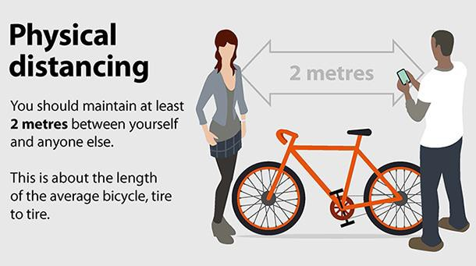

Injury or Mechanical
- We recommend that a mechanical only be worked on by one coach or ride leader.
- When bikes are serviced by a ride leader, wipe down before and after with a sanitizing wipe.
- We recommend that all persons use hand sanitizer before & after.

- Ride leaders should consider carrying PPE equipment (gloves, mask, first aid kit, sanitizer) with them during rides to be prepared for any potential injury situation that needs to be addressed.
- If there is an injury, we recommend that the person providing medical aid put on PPE before assisting the injured participant.
- If close encounters are necessary, it is recommended that you to try and limit your time with another individual to 10 mins.
- If there is an injury, we recommend that the person providing medical aid put on PPE before assisting the injured participant.

After Your Ride / When you get home from the ride
- Use Hand Sanitizer before you pack up & touch your other belongings or your car.
- Wash up when you get home.
- Clean and disinfect frequently touched objects and surfaces (Bicycle handlebars, brake levers and gear shifters).

NOTE: As the guidelines provided by the Health Authorities change, the protocols required for club rides and training may need to be adjusted.

Questions or Comments? Please contact:
Marty Gaudet - Kids of Mud Race Director: kom.mbcycling@gmail.com or
The MCA office at 204-925-5686

STAY SAFE – HAVE FUN!

